**PaNOSC**

**Photon and Neutron Open Science Cloud**

**H2020-INFRAEOSC-04-2018**

**Grant Agreement Number: 823852**

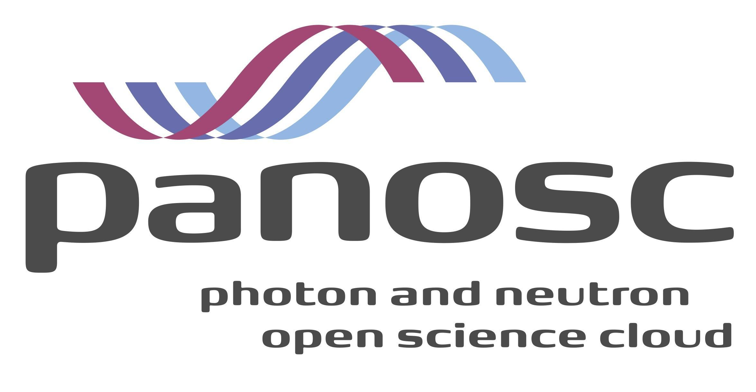

**Deliverable D8.4: Closing report including report from summer school**

# **Project Deliverable Information Sheet**

|  |  |
| --- | --- |
| Project Reference No. | 823852 |
| Project acronym: | PaNOSC |
| Project full name: | Photon and Neutron Open Science Cloud |
| H2020 Call: | INFRAEOSC-04-2018 |
| Project Coordinator | Andy Götz (andy.gotz@esrf.fr) |
| Coordinating Organisation: | ESRF |
| Project Website: | www.panosc.eu |
| Deliverable No: | D8.4 |
| Deliverable Type: | Report |
| Dissemination Level | Public |
| Contractual Delivery Date: | 30/11/2022 |
| Actual Delivery Date: | 05/12/2022 |
| EC project Officer: | Flavius Alexandru Pana |

## **Document Control Sheet**

|  |  |
| --- | --- |
| **Document** | Title: |
| Version: 1 |
| Available at: https://github.com/panosc-eu/panosc |
| Files: 1 |
| **Authorship** | Written by: Andrew McCluskey & Thomas Holm Rod |
| Contributors: Peter Willendrup |
| Reviewed by: Andy Götz |
| Approved: Jordi Bodera |

## **List of participants**

|  |  |  |
| --- | --- | --- |
| **Participant No.** | **Participant name** | **Country** |
| 1 | European Synchrotron Radiation Facility (ESRF) | France |
| 2 | Institut Laue-Langevin (ILL) | France |
| 3 | European XFEL (XFEL.EU) | Germany |
| 4 | The European Spallation Source (ESS) | Sweden |
| 5 | ELI European Research Infrastructure Consortium (ELI-ERIC) | Belgium |
| 6 | Central European Research Infrastructure Consortium (CERIC-ERIC) | Italy |
| 7 | EGI Foundation (EGI.eu) | The Netherlands |

## 

# **Introduction**

This report encompasses Deliverable D.8.4 “Closing report including report from summer school, task 8.8” where task 8.8 is “**PaNOSC schools for students**”.

The report summarizes the work of PaNOSC Work Package 8 (WP8) over the duration of the funding, providing information about the future plans for the services developed, and reporting on the successful PaNOSC summer school held in Szeged, Hungary in September 2022. The focus of WP8 was as follows:

* The development and delivery of an e-learning platform that can be used across the neutron and photon facilities.
* Staff training in data stewardship and the e-learning platform.
* User training in PaNOSC services and facilities.

This work package has been co-led by the European Spallation Source (ESS) and Extreme Light Infrastructure (ELI), with input from other partner facilities.

The e-learning platform based on e-neutrons.org has been developed and is available at <https://e-learning.pan-training.eu>. This platform is built on the open-source Moodle learning management system and includes the integration of MediaWiki. The Moodle and MediaWiki services are complimented by the integration of Jupyter Notebooks that can be launched from the learning material. The PaN-Training catalogue (developed as a component of the ExPaNDs project) integrates courses developed in the e-learning platform, such that these automatically appear as catalogue items.

# **Closing report**

# **Sustainability and maintainability**

# Task 8.1 (Sustainability and maintainability of e-learning platform) outlined the goal to transfer the e-neutrons.org service to ESS infrastructure and facilitate the long-term maintenance and support of the service. This has been achieved, with the e-learning platform (now known as PaN-training e-learning) hosted fully at ESS’s Data Management and Software Centre. Furthermore, the responsibility for the long-term support of the e-learning platform has been taken on by the Scientific Web Applications (SWAP) subdivision of the DMSC. We note that the domain name, e-learning.pan-training.eu is used to provide a single landing page for the e-learning platform and PaN-training catalogue from ExPaNDS.

# The integration of the e-learning platform into the SWAP subdivision will ensure the long-term maintenance of the platform. Furthermore, when the ESS facility is operational the e-learning platform will be used for user training, in particular on subjects of data reduction and analysis. Additionally, this will help to resource future developments of the e-learning platform based on the needs of the training provided. The LEAPS Data Strategy for 2023-2030 states that LEAPS facilities should adopt the PaN-training portal, including where relevant the e-learning platform. We believe that demand for the e-learning platform will be a driving force for future developments.

# **Jupyter integration**

# One of the most unique deliverables of this project is enabling integration between the JupyterHub instance and the Moodle platform. The integration of the e-learning platform at ESS has in turn facilitated the availability of access to a JupyterHub system that runs on ESS compute resources. The JupyterHub is integrated in the authentication of the e-learning platform, meaning that a seamless transition from the Moodle content to the JupyterHub is possible in courses. This integration has been used extensively in courses, including the recent PaNOSC summer school (discussed below). This integration provides a “unique selling point” for the e-learning platform to integration technical Jupyter-based content in the course enabling a greater level of active learning for the student and was very positively reviewed by students at the PaNOSC summer school. Finally, there are plans for future user experience enhancements that will be pursued in upcoming projects (see Future plans for the e-learning platform section below).

# **Collaboration**

# Throughout the PaNOSC and ExPaNDS projects, there has been a close collaboration between PaNOSC WP8 and ExPaNDS WP5. ExPaNDS WP5 has been responsible for the delivery of the PaN-training catalogue. Through this close collaboration, it has been possible to include e-learning courses within the PaN-training catalogue in an automated fashion and enable a shared brand identity across both the training catalogue and the e-learning platform. This has been achieved with weekly joint technical meetings. We plan to sustain this collaboration beyond the current project given the clear complementary nature of the two projects.

# **Training**

# In early 2021, among COVID restrictions, a two-part online workshop was held, organised by Prof. Jesper Bruun from the Department of Science Education University of Copenhagen. The aim for this workshop was to introduce those within the photon and neutron community to pedagogical concepts that would be relevant in creating content for the e-learning resource. Details regarding the workshop can be found in the deliverable 8.2 report entitled “Lessons learned and future prospects for adopting the e-learning platform pan-learning”.

# In addition to this formalized workshop, training of content creators has been conducted regularly by the maintainers of the platform to engage the use. To this end there are courses available on the e-learning platform that introduce simple topics that may be of interest to those working to develop new material, such as “[Creating a Video Mini-Lecture](https://e-learning.pan-training.eu/moodle/course/view.php?id=69)” and “[Including Jupyter Notebooks in your Course](https://e-learning.pan-training.eu/moodle/course/view.php?id=70)”.

# **Usage**

A detailed report on the usage is given in the deliverable report 8.2, however, here we will provide and update on the usage of the e-learning platform by the photon and neutron community. It was previously reported that the e-learning platform had 707 registered user account. Since this time (deliverable report submitted at the end of May 2022), the number of registered accounts has increased to 925. Currently, there are 55 courses hosted at the e-learning platform and another 17 “Under Construction”, although not all courses are publicly available. The subjects covered by these courses range from Python programming to publication guidelines and cover the range of photon and neutron science. In approximately the last year, these have included workshops on:

* Neutron scattering delivered at the University of Copenhagen;
* Small angle neutron scattering delivered by ESS staff as a component of the Swedness PhD Training;
* Material Science at European Large-Scale Infrastructures using Open and FAIR data, i.e. the PaNOSC Summer School (discussed in detail below);
* Photosynthesis and Energy delivered at the University of Amsterdam;
* ISIS Virtual Reflectometry Training Course delivered by the ISIS Neutron and Photon Source, with input from other facilities.
* TU Delft course on Neutrons, X-rays and Positrons for studying microscopic structures and dynamics.

In the figure below, we show the cumulative logins to the e-learning platform (blue) and cumulative course enrollments (green) both as a function of time.

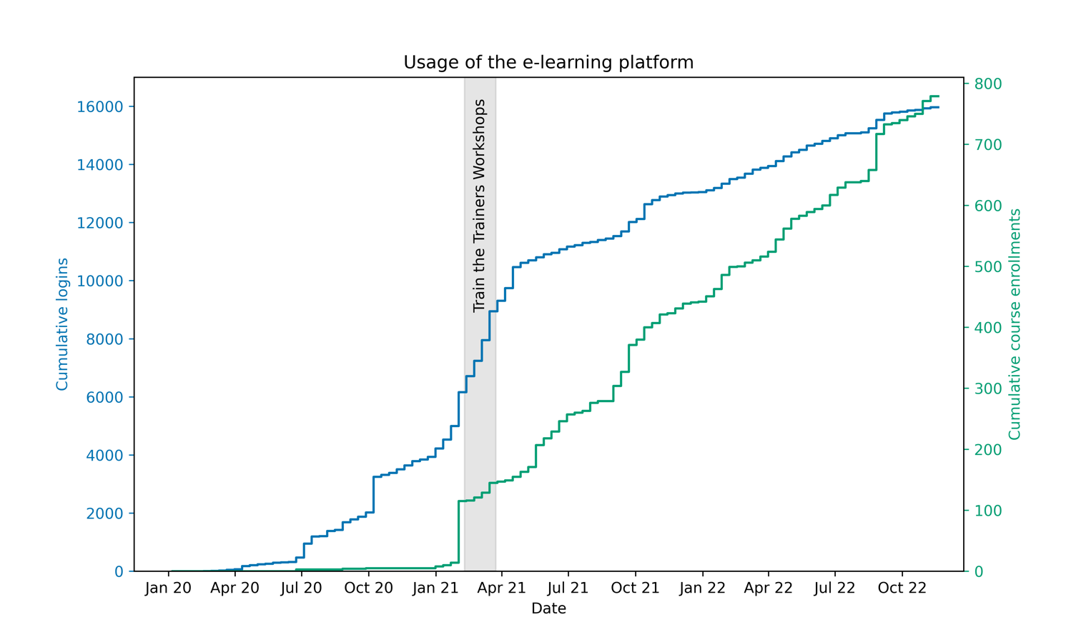

# **Future plans for the e-learning platform**

Some aspects of the future plans for the e-learning platform are discussed above. Here, we will give more detail on them individually:

* Continued support from the SWAP team at ESS’s DMSC. The SWAP team have recently worked to simplify the technology stack for the e-learning platform even further than achieved in MS8.1, while keeping the same functionality available. In addition to reducing the maintenance load, this has helped to develop competency in working with the e-learning platform within the SWAP team. The SWAP team will continue to maintain the platform long-term.
* Improvements to Jupyter integration. The current integration of the JupyterHub within the e-learning platform is very powerful for engaging students in active learning. However, there are additional improvements that can be made. These include the transfer of data between the JupyterHub and the e-learning platform (this would be a powerful feature when applied to grading results from the JupyterHub using Moodle’s gradebook functionality) and enabling the launching of a specific single Jupyter notebook document directly from Moodle. Both of these features are of interest to the SWAP team as a component of ESS operational readiness.
* Institution of policy requiring courses to be kept up to date.
* Continued engagement with potential content creators.

# **Report from Summer School**

The PaNOSC summer school **Material Science at European Large-Scale Infrastructures using Open and FAIR data** was held September 12-16 in Szeged, Hungary. This summer school was aimed at introducing participants to open and FAIR data and highlighting the role of these in materials science studies at large-scale infrastructures.

# **Summary**

The motivation behind the organisation of a PaNOSC summer school was to promote the importance of data, in particular FAIR data, within the user communities of the large-scale facilities in Europe and to emphasize the role of data reduction, analysis, modelling and management as a fundamental component of a large-scale infrastructure experiment. Furthermore, this summer school would draw attention to the work conducted within the PaNOSC project. To this end we aimed to:

1. enable scientists to better leverage the European Research Area by guiding scientists towards the facility where the cost-benefit is the highest,
2. promote the FAIR principles, and
3. introduce students to the services concepts developed in PaNOSC.

We chose to focus the summer school around a single scientific application area, namely Energy Materials, to help direct users of the PaNOSC facilities to engage in the event.

The content for the school included:

* training in Python programming (important for accessing many FAIR data tooling, <https://e-learning.pan-training.eu/moodle/course/view.php?id=108>),
* an introduction to FAIR data and FAIR data management (<https://e-learning.pan-training.eu/moodle/course/view.php?id=114>),
* three science focus days (laser, neutron and X-ray) looking at the importance of FAIR data in application of these techniques to materials science (<https://e-learning.pan-training.eu/moodle/course/view.php?id=111>, <https://e-learning.pan-training.eu/moodle/course/view.php?id=109>, and <https://e-learning.pan-training.eu/moodle/course/view.php?id=110>, respectively), and
* a final day where the students were grouped into teams to prepare a beamtime proposal.

All of the training (except the more conceptual final day) made use of the PaN-training e-Learning platform as well as the JupyterHub integration that is available through this. Both of these products are the result of the PaNOSC project.

The organisation of the school was performed by staff from ELI-ERIC, ESS, and CERIC-ERIC (via WP9). The school took place at the Szeged Art Hotel and the ELI-ALPS campus and included a tour of the ELI-ALPS facility with introductions to the laser facilities present there.

The Python training aimed to introduce the students that were unfamiliar with the Python language in a clear and concise manner. This built on training previously performed at the European Spallation Source and was led by Mads Bertelsen (ESS). The FAIR data introduction was delivered by Andy Götz (ESRF) representing the PaNOSC project at large.

The laser focus day was organised by Dr Mousumi Upadhyay Kahaly (ELI-ALPS) and offered a broad introduction to laser science before looking in detail into how measurements at the high-intensity light sources may be interpreted. The students were introduced to simple modelling approaches to analyse laser pulse datasets before moving on to focus on how time-dependent density functional calculations of molecular systems could be used to complement these measurements. The laser focus day was followed by a tour of the ELI-ALPS facility.

The neutron focus day was organised by Dr Andrew McCluskey (ESS), who started the day with and introduction to quasi-elastic neutron scattering (QENS) and its importance in the study of battery materials. The students where then tasked with finding literature values for diffusion in lithium containing materials and modelling the resulting QENS data (guided by Jupyter Notebooks). The students then prepared open and FAIR datasets of these modelled results and shared them with their colleagues. An open session was run where the group investigated each dataset (using the HDF5 viewer developed within PaNOSC WP4) and commented on the ”FAIRness” of each dataset. Finally, the students were presented with a real dataset for a lithium containing material and tasked with analysing this using what they learned. The results of these analyses were also shared FAIRly.

The X-ray focus day was organised by Marius Retegan (ESRF). This began with a lecture from Pieter Glatzel (ESRF) introducing synchrotron radiation and the fundamentals of X-ray spectroscopy, focusing on the importance of data and modelling in this technique. Following this introduction, the students were shown an overview of data analysis tools for X-ray spectroscopy before being allowed to reduce and analyse experimental dataset. Finally theoretical approaches to interpret X-ray spectra were used to complement the previous analysis. All of this was performed on FAIR data, that is shared via the ESRF open data portal.

The final day involves the students being split into groups to prepare a short beamtime proposal. The focus of this proposal was not scientific but rather to enable the students to understand the importance of considering the data pipeline in their proposal, showing that they understood the role of data in large-scale infrastructure experiments. Throughout this session all of the lecturers were on hand to assist the students in this work. This resulted in three exciting proposals from the students, where the importance of data analysis and management was playing a leading role. The students ended the day with a pitch session for their proposals, where short five-minute presentations were given.

# 

# Summer school group photo

# **Feedback**

In total 28 participants (21 attended) were selected from over 60 applications to participate in the five-day school, a breakdown of nationality of the participants is shown in the Figure below.

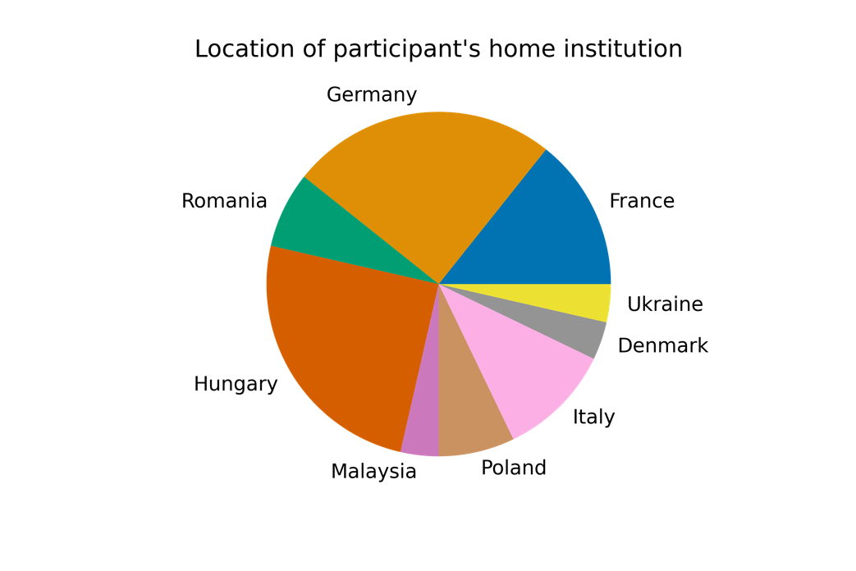

Following summer school attendance, the students were asked to provide feedback on their experience, with 10 responses received. The table below shows the questions that were asked in the feedback form and the average rating of agreement and standard deviation (from 1 to 5).

|  |  |
| --- | --- |
| **Question** | **Rating** |
| The PaNOSC Summer School was well organised and enough information was provided in advance | 4.6 ± 1.0 |
| Overall, the talks were clearly presented and easy to follow | 4.4 ± 0.8 |
| The talks were pitched at the right level | 4.5 ± 0.7 |
| The length of the talks on FAIR principles was just right | 4.1 ± 1.2 |
| The length of the talks on Jupyter and Python was just right | 3.8 ± 1.2 |
| The length of the talks on the laser day was just right | 3.8 ± 1.3 |
| The length of the talks on the neutron day was just right | 4.4 ± 0.5 |
| The length of the talks on the X-ray day was just right | 4.4 ± 0.7 |
| The training material provided was clear and useful | 4.6 ± 0.8 |
| The length of the sessions on proposal writing was just right | 4.0 ± 1.3 |
| The sessions on proposal writing gave me useful insights for my future research projects at large-scale research infrastructures | 4.3 ± 1.2 |
| The sessions on lasers were clear and easy to follow | 3.8 ± 1.3 |
| The sessions on neutrons were clear and easy to follow | 4.3 ± 0.8 |
| The sessions on X-rays were clear and easy to follow | 4.5 ± 0.7 |
| The hands-on session on data analysis and simulation were clear and easy to follow | 4.1 ± 1.1 |
| The hands-on session provided the knowledge needed to master the tools for data analysis and simulation | 4.3 ± 1.1 |
| The PaNOSC summer school met my expectations | 4.4 ± 1.0 |
| I gained valuable insights and a better understanding of the data tools for research at photon, neutron and laser facilities | 4.2 ± 1.0 |
| I gained a better understanding of the benefits of the data tools presented | 4.1 ± 1.2 |

Nearly all of the feedback items received a positive rating above 4. In particular, we draw attention to the 4.4 ± 1.0 rating for “The PaNOSC summer school met my expectations” as an indicator of the student’s enjoyment of the summer school. In the Figure below, we show a pie chart of the responses to the feedback form.

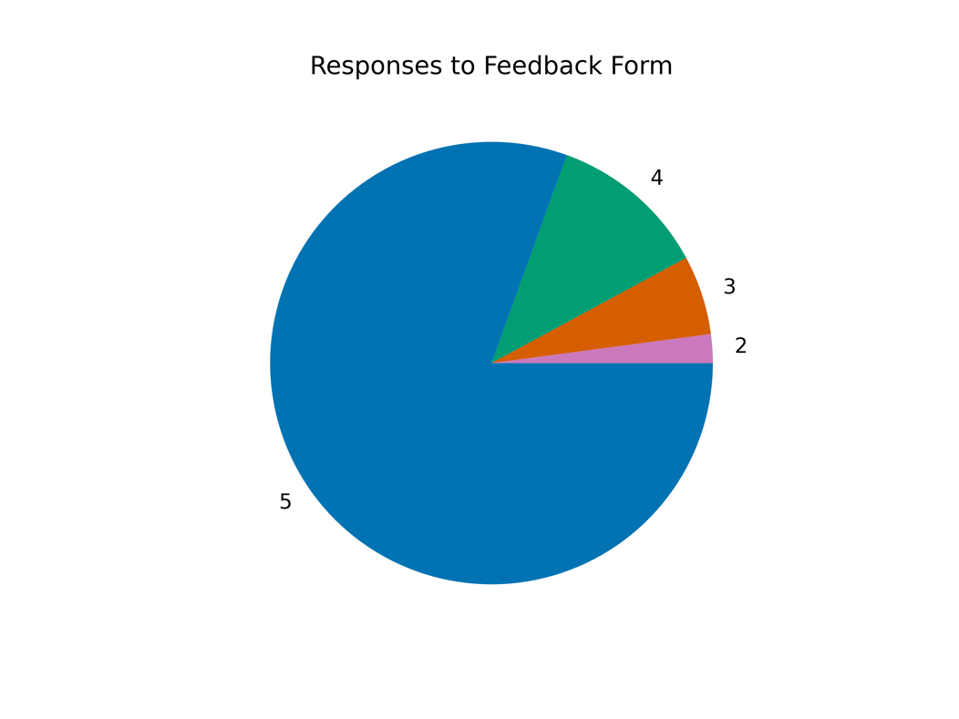

It can be seen that the majority of responses gave the positive 5 out of 5 rating. In addition to the feedback questions, the students were asked to provide additional comments (if necessary), these included:

* *The e-learning platform is very useful and the lectures/slides on it are very detailed, especially the hands-on parts are easy to follow up as they provide each step and its logic. It is worthwhile to preserve it since we can go on using and learning it after summer school.*
* *This was my first international summer school that I have attended, I got a lot of information. The most important thing for me and what I like the most is the hands-on training, during which I learned a lot.*
* *Very well-organized Summer School with clear talks*

There was additional feedback from the students suggesting that in future, there should be an explicit requirement for Python programming ability:

* *I think, the requirement for to participate in the PaNOSC course need to have at least intermediate level of experience in using Python and Jupyter, so that they can follow the hand-on simulation smoothly.*

In addition to this formalised feedback, student feedback during the school was also very positive and productive. A result of these feedbacks is the plans to adapt the neutron focus day e-learning module into a standalone object, including some specific feedback points from the students.

# **Lessons Learned**

Even with the positive feedback from the students that participated, it is still important to understand how such event could be improved in future. To this end, a lessons learned review session was held within the ESS participants to identify improvements that could be undertaken in future, as well as note successes of the event.

Successes:

* The non-technical planning by ELI-ALPS, ESS, and CERIC-ERIC staff was fantastic.
* The e-Learning platform and JupyterHub integration worked perfectly throughout the school.
* The students particularly enjoyed the hands-on sessions where they were challenged with problem solving.

Improvements to be made:

* The three science focus days could have been more cohesive and shown better the complementarity of the techniques, though it was accepted that this is the nature of organising a school over three facilities.
* Time management for all days could be improved, i.e., every day (except the first) would have run over if not for the efforts of the lecturers to remove components they had planned to teach.
* Due to delays in organisation, the school didn’t have quite long enough time for advertising the event.